**Master/Bachelor Thesis / Project Offer**

Overall Topic:

**How can clay minerals impact the toxicity of copper**

**oxide nanoparticles towards soil organisms?**

**You are interested in:**

**Background:** Copper-based nanoparticles are currently used as fungicides in agriculture. Up to now, no toxicity of copper oxide nanoparticles (CuO-NP) towards soil invertebrates had been proven. However, soil bioassays had been conducted only in sandy soils with low clay content. In contrast, in our experiments we found strong impact of CuO-NP on the reproduction of the springtail *F. candida*, but only in loamy soils with high clay content. Surprisingly, this effect was strongest at the lowest tested concentrations. We hypothesize an interaction of CuO-NP with clay minerals in soil which impacts their toxic properties, probably by coating and aggregation.

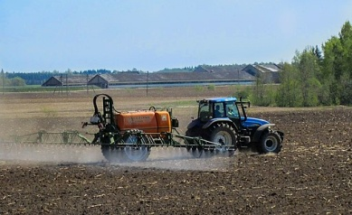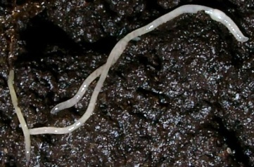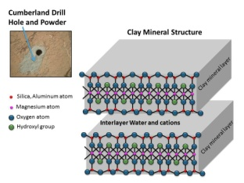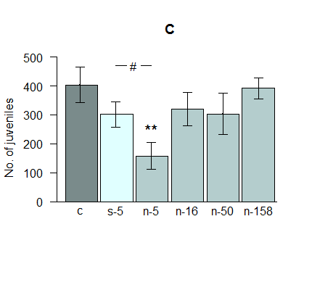

**Topics:** Research projects within the overall topic can be conducted in many different scientific disciplines, such as ecotoxicology, molecular biology, but also electrochemistry. Most important is your personal interest and excitement for the topic. The specific content of your work will be discussed in communication with your supervisor. Some suggestions for suitable research questions are:

* **How do different clay types affect the bioaccumulation and elimination of copper oxide nanoparticles (CuO-NP) in soil invertebrates?**
* **Can observed effects be explained on a molecular level via biomarkers?**
* **How is the chemical behaviour of CuO-NP in soils driven by clays?**
* **Does the soil type have an impact on the reproduction of the white worm *Enchytraeus crypticus* when exposed to CuO-NP?**